1. Introduction

The IIS Authentication Filter enables the Microsoft Internet Information Services (IIS) to use LDAP directories for user authentication. This can be an extremely useful capability for an enterprise where the primary directory service is stored in a non-Microsoft platform and it must be integrated with Microsoft IIS applications.

Most commercial solutions for integrating IIS with LDAP directories involve synchronising an Active Directory tree with the primary LDAP directory source. While this may be appropriate for certain situations, it is usually expensive and non-trivial to configure. The IIS Authentication Filter simply allows IIS applications to rely on an LDAP source for authentication and does not provide any directory tree synchronisation.

1.1 Document Conventions

The following terminology and definitions are essential to understanding the IIS LDAP Authentication Filter documentation:

Item | Definition or Purpose
IIS | Microsoft's Internet Information Services. A W3C-compliant web server included with Microsoft Windows NT 4.0 and later. Version 5.0 is included with Windows 2000/XP. Version 6.0 is included with Windows Server 2003.
ISAPI | Internet Server Application Programming Interface. Software developers can create extension and filter modules for IIS using ISAPI. The IIS LDAP Authentication Filter uses ISAPI to modify the IIS authentication process.
LDAP | Lightweight Directory Access Protocol. A quasi-standard from the mid-1990s for simplified directory access, querying, and modification. Most directory systems including Microsoft Active Directory, Novell eDirectory, and Sun ONE provide an LDAP interface, at the minimum, to read directory data.
Directory Tree (Tree) | Due to the hierarchical nature of an LDAP directory, a particular database is generally referred to as a “tree” or “directory tree”.
NT Local Security | All Windows Server installations use at least one source for user authentication. For servers that are not part of an Active Directory Tree, the local security policies are used. Windows 2000/XP Professional Editions use local security if they are not configured for an NT domain or Active Directory.  The IIS LDAP Authentication Filter will need either an NT Local Security User or an Active Directory User to authenticate LDAP users.

1.2 Intended Audience

This document is intended for system administrators for Windows 2000/XP/2003 servers. A strong knowledge of Microsoft IIS, NT Local Security or Active Directory, and LDAP services is required to successfully install the IIS LDAP Authentication Filter.

1.3 Contact Information

Primary Authors:

Ram Rajadhyaksha
Inflection Technology, LLC
http://www.inflectiontech.com
Email: ramr@inflectiontech.com

1.4 References

LDAP and eDirectory Integration, Novell Developer Kit, Novell, Inc. (Mar 1, 2006) Retrieved from
http://developer.novell.com/documentation/ldapover/pdfdoc/ldap_enu/ldap_enu.pdf on December 14, 2006.

Internet Information Services 6.0 SDK, Microsoft Corporation. Retrieved from http://msdn.microsoft.com/library/default.asp?url=/library/en-us/dnanchor/html/anch_iis.asp on December 14, 2006.
2. Installation

The process of installing the IIS LDAP Authentication Filter is relatively easy. However, various environment-specific issues can create problems for the system administrator. Please take close consideration for the following steps to install the software.

2.1 Download the Novell eDirectory LDAP SDK

The LDAP IIS Authentication Filter uses Novell's LDAP Software Development Kit (SDK) for LDAP server communications. The package is available for free from Novell. To obtain a copy of the SDK, visit the following links:

http://developer.novell.com/wiki/index.php/Developer_Home
http://developer.novell.com/wiki/index.php/LDAP_Libraries_for_C

2.2 Installation of the Novell eDirectory LDAP SDK

Once a copy of the LDAP SDK has been obtained, extract the contents of the archive. As of December 2006, the SDK has the following file tree:

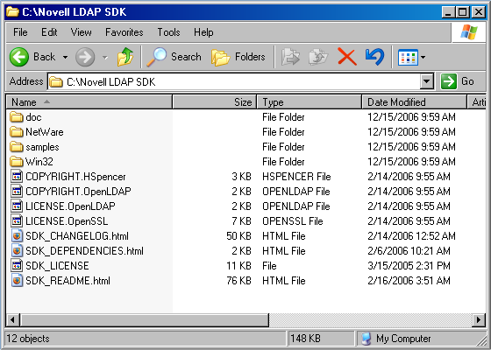

Figure 2.1: The Novell LDAP SDK Files

The SDK contains documentation, programmatic code, header files, and shared libraries. For the purposes of installing the IIS LDAP Authentication Filter, only the shared libraries are required.

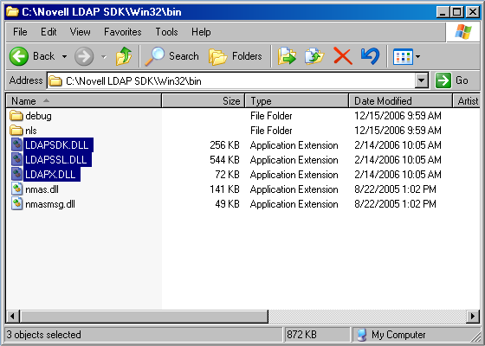
Figure 2.2: Required LDAP SDK DLLs

Locate the three shared libraries LDAPSDK.DLL, LDAPSSL.DLL, and LDAPX.DLL from the SDK files and copy the files to c:\windows\system32.

❖ Note: The system32 directory on most Windows XP and 2003 installations is in
c:\windows\system32\. For Windows 2000 or NT 4.0, it is usually
c:\winnt\system32\. This location can be environment-specific.

2.3 Testing the Novell eDirectory LDAP SDK

It is important to verify that the LDAP functionality is actually working. Use the ldapsearch.exe application located in the win32\tools\ directory of the SDK files. The ldapsearch.exe file is a console application and must be started from a command prompt.

A few example tests may include querying the LDAP server to look up a specific user record, querying for a set of records, and authentication to the LDAP server. For this document, we shall assume our LDAP directory server to have an IP address of 192.168.1.1 and a default search tree of “o=default”.

An example of querying for a user record using an anonymous bind:

ldapsearch -h 192.168.1.1 -b “o=default” “uid=myuserid”

An example of querying for a user record using an authenticated bind:

ldapsearch -h 192.168.1.1 -b “o=default” -D “uid=binduser” -w “password” “uid=myuserid”

The ldapsearch.exe tool will print out detailed record information if the request succeeded:

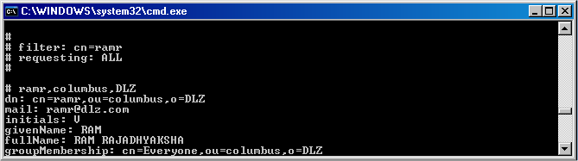
Figure 2.3: ldapsearch.exe output

2.4 Installing the iisldapauth.dll

It is recommended that the iisldapauth.dll file be placed in:

C:\windows\system32\inetsrv\ (Windows XP or 2003)
C:\winnt\system32\inetsrv\ (Windows 2000)

In general, most ISAPI modules are placed in the location specified above. The module will work in any directory location where the IIS process has read-access.

2.5 Installing the ldapauth.ini Configuration File

Copy the ldapauth.ini file provided with the IIS Authentication Filter package to the Windows directory:

C:\windows\ (Windows XP or 2003)
C:\winnt\ (Windows 2000)

2.6 Configuration of IIS

The IIS LDAP Authentication Filter must be installed in the IIS Administrator Console. This can generally be reached by choosing Internet Information Services from the Administration program group.

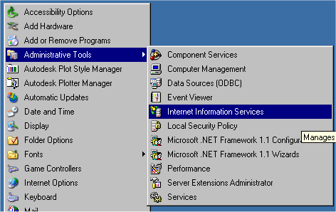
Figure 2.4: Internet Information Services Administration Console

Select the Web Site for which the IIS LDAP Authentication Filter should be installed. Most IIS installations generally have one default web site. Choose Properties from the contextual menu to configure the web server.

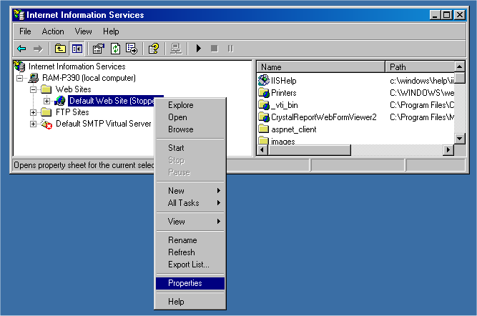

Figure 2.5: Choosing the Properties of the Default Web Site

The Web Site Properties dialog box will appear. Click on the ISAPI Filters tab to view the list of loaded ISAPI modules. Most IIS installations generally do not have any other ISAPI filters.
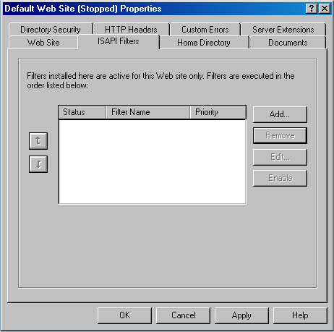
Figure 2.6: Web Site Properties Dialog / ISAPI Tab

Click the Add button and complete the Filter Properties dialog box. Name the filter by typing ldapauth into the Filter Name text box. Locate the iisldapauth.dll file using the Browse button. Once this has been completed, click on the OK button.

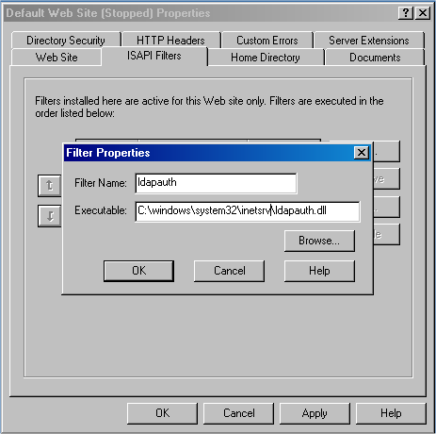
Figure 2.7: Adding the LDAP Authentication Filter

Click through the OK buttons until every dialog has closed. At this point, the IIS LDAP Authentication Filter should be installed.

2.7 Reload the W3C Process

The IIS service must be reloaded to enable the IIS LDAP Authentication Filter. To do so, the following commands must be typed at the command prompt:

net stop w3svc
net start w3svc

Once the service has restarted, look at the ISAPI Filters properties once again to verify the module has loaded successfully:

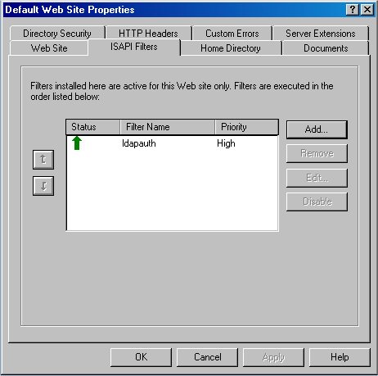
Figure 2.8: LDAP Authentication Filter Status

If a red down arrow appears, the filter did not load successfully. An incorrect syntax in the ldapauth.ini configuration file or failure to install the Novell LDAP SDK shared libraries are usually the cause of module loading failures.

3. Configuration File Directives

Directive | Required? | Description
LDAPHOST | Required | The IP address of the LDAP server. DNS names are not allowed at this time.
LDAPPORT | Optional | The port number for the LDAP connection. The default port is tcp/389. If a CERTSFILE directive is specified, the default port will be tcp/636.
BINDUSER | Optional | A valid LDAP DN for authenticating to the LDAP server specified by the LDAPHOST directive.
BINDPASSWORD | Optional | The password for the BINDUSER. If this is not specified, a blank password will be used.
LDAPFILTER | Required | A standard LDAP query string used for restricting the search to specific attributes. The authenticating username is inserted into the filter by the key %user%.  Example: If my filter is (cn=%user%) and the user "bob" tries to authenticate, the LDAP filter query would be (cn=bob).
SEARCHBASE | Required | The LDAP search base.
NTUSER | Optional | The NT user mapped to LDAP users. If this is specified, all LDAP users will be authenticated to the IIS security as that particular NT user.
NTPASSWORD | Required | The password for the mapped NT user. If NTUSER is specified, the NTUSER value will be used as the username. If NTUSER is not specified, the LDAP username will be used.
CACHESIZE | Optional | The number of user records that can be stored in a memory cache.
CACHETIME | Optional | The lifetime of a cache record in seconds. Example: 1800 for 30 minutes.
LOGFILEPATH | Optional | A Windows path to a log file. Access and debugging information will be written to this log file. Note: this will affect performance to a significant degree.
LOGLEVEL | Optional | Valid values: WARN, DEBUG
CERTSFILE | Optional | The SSL certificate file to use a secure connection. If this is specified, LDAPPORT will default to 636 unless specified explicitly in the configuration file.

